Key words:

commitments to the CRPD, quality of life of citizens with disabilities, relationship, general QOL indicators, disability specific QOL indicator, correlation,

Key paragraphs:

individuals with disabilities from countries who have made a weaker commitment to the CRPD (i.e., signed convention) should predictably have a lower quality of life than individuals with disabilities from countries that have made stronger or the strongest commitment to the CRPD (i.e., ratified convention & protocol).

To see whether their relative quality of life reflects their country’s level of commitment to the CRPD, their scores for each QOL indicator would be compared to their country’s level of commitment to the CRPD to observe alignment.

Then, each QOL indicator would be inputted into a multiple linear regression model to confirm of the existence of a statistically significant relationship with the CRPD which would help with deciding whether this convention is truly meaningful.

Thus, to ensure that a larger sample that is inclusive of individuals with disabilities from both OECD and non-OECD countries was available for use, general QOL indicator data was included in this paper as replacement.

Great efforts were put into collecting disability specific QOL indicator data, but just for a few individual countries rather than all countries endorsing the CRPD. These few countries were those whose majority of general QOL indicator scores appeared to align with/be reflective of their CRPD commitment level.

An example of such a country is one that made the highest level of commitment (ratified the convention and optional protocol) and had the best scores for majority of general QOL indicators. Measures/scores for disability specific QOL indicators would then be searched for this country to see if they align with their measures/scores for the general QOL indicators.

histograms all general QOL indicator data that was collected for our sample of countries. The data of each general QOL indicator will be discussed in the context of whether it reflects the level of commitment these countries made to the CRPD.

Our sample consists of sixty-two CRPD endorsing countries (inclusive of both OECD and non-OECD countries). They were randomly selected from the United Nations’ (n.d.) CRPD ratification/signature list available online.

In other words, since the CRPD distribution is heavily positively skewed towards the highest levels of commitment, it is being seen whether the general QOL indicator distributions are also skewed towards the best/highest scores.

It must be clarified before continuing that viewing alignment via comparing distributions is not considered as evidence of the CRPD being meaningful to the quality of life of individuals with disabilities. It is rather considered as only being weakly suggestive of the possibility of the CRPD being meaningful.

*CRPD Levels of Commitment*

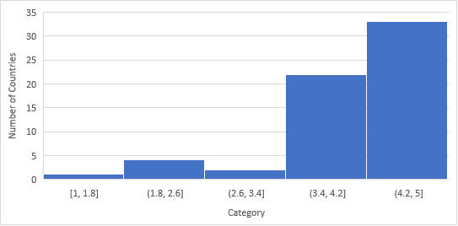

This means that almost every single country in this sample chose to ratify the convention (category 4) or ratify it alongside its optional protocol (category 5). If the CRPD truly holds meaning for QOL, then based on this histogram, the QOL of people with disabilities in most countries should be exceptionally good. In other words, it should be seen that the general QOL indicator scores reflects/aligns with this positively skewed distribution of the CRPD levels of commitment data. Reflection/alignment will be determined in this next section after the disability specific QOL indicators have been described and explained.

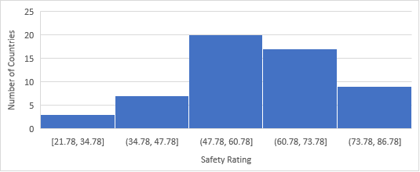

This is as the distribution of the safety data is not at all skewed towards the best/highest scores (as is the CRPD distribution) that indicates high quality of life. Thus, the scores for this general QOL indicator are not reflective of the distribution of the CRPD commitment level data.

…

According to the analysis that was just performed in the previous sub-section, majority of the data distributions of the general QOL indicators (besides life expectancy and unemployment rate) did not at all align with/seem to reflect the distribution of the CRPD commitment level data.

Nonetheless, to definitely confirm that there lacks a relationship between the CRPD and the general QOL indicators, a multiple linear regression was performed.

Eight countries (all non-OECD) were removed from the sample before running this test due to them missing data for a couple of indicators. The multiple regression revealed that a small fraction of the variance in CRPD commitment levels can be explained by the general QOL indicators, adjusted R² = .29, F (10, 43) = 1.78, p = 0.09

**Do They Align: Comparing the Disability Specific QOL Indicator Data with General QOL Indicator Data for Specific Countries**

1. CRPD category
2. Masculinity index
3. The country list is from the CRPD website, meaning that it’s a list of countries with CRPD endorsement. CRPD index: 2-5
4. Disability Specific Indicators of Quality of Life:

***Employment Rate,***

***Minimum Educational,***

***Attainment,***

***Anti-Discrimination Disability Legislation***

1. General Indicators of Quality of Life:

***safety,***

***life expectancy,***

***gross domestic product (GDP) per capita,***

***unemployment rate, democracy,***

***corruption,***

***global freedom,***

***power distance,***

***long term orientation,***

***masculinity.***